
APP Services

SNS
SQS
SWS

Amazon SNS (Simple Notification Service)

- SNS: SNS is integrated into many AWS services. We are able to use it to receive notifications when events occur in our AWS Environment. With CloudWatch and SNS a full environment monitoring solution could be created that notifies administrators of alerts, capacity is sues, downtime, changes in the environment, and more!

- TOPIC: A topic what a “message is sent to”

- Subscription end point: SNS sends all messages to subscriptions subscribed to a specific topic

- Subscriber end points include the following

  - Application, Mobile APP notifications (IOS/Android/Amazon/Microsoft) SMS

  - HTTPS

  - JSON

  - E-Mail JSON

  - SQS Queue

Amazon SQS (Simple Queue Service)

- SQS: Hosted/ highly available queues used for messages being sent between computers. SQS allows the creation of distributed/ decoupled application components.

- Each message can contain up to 256KB of text in any format

- Amazon SQS guarantees delivery of each message at least once BUT DOES NOT guarantee the order (best effort) in which they are delivered to the queue, in other words it does not guarantee first in first out order. SQS is also highly available and redundant managed service by design

- Used for created decoupled application environments

- SQS does not guarantee there will be no duplicate messages sent to the queue

- Generally a “worker” instance will “poll” a queue to retrieve waiting messages for processing

- Auto Scaling can be applied based off of queue size s o if that component of your application has an increase in demand worker instances can increase

QS

Two types of polling

Long Polling

- Allows the SQS service to wait until a message is available in a queue before sending a response (reduces API requests ) and will return all messages from all SQS services

Short Polling

- SQS samples a subset of servers and returns messages from jus t those servers.

- Will not return all possible messages in a poll § Increases api requests which increases costs

Decoupled/Distributed Architectures

- Tightly Coupled System – A system architecture of components that are not just linked together but are also dependent upon each other

  - If one component fails all components fail

- Loosely Coupled/Decoupled Systems – Multiple components that can process information without being connected

- Components are not connected if one fails the rest of the system can continue processing – fault tolerant/highly available.

AWS Services that are used for distributed/decoupled system architectures

- SWF (Simple Work Flow Service)

- SQS (Simple Queue Service)

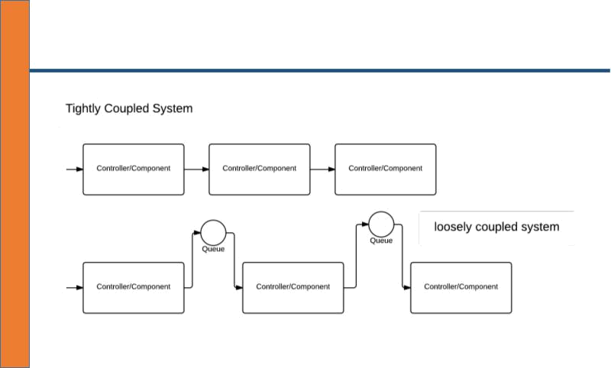

Simple Work Flow

- SWF is a fully managed “workflow” service by AWS. Workflows allows an architect/developer to implement distributed, asynchronous applications as work flows.

- What is a work flow? A work flow coordinates and manages the execution of activities that can be run asynchronously across multiple computing devices.

- Tasks are what interacts with the “workers ” that are part of a work flow

  - Activity task – Tells the worker to perform a function

  - Decision task – Tells the decider the state of the work flow execution which allows the decider to determine the next activity to be performed

- A worker and decider can be any type of component s uch as an EC2 instance or even a person!

- SWF has consistent execution and guarantees order in which tasks are executed and that there are no duplicate tasks.

- The SWF service is primarily an API which application can integration the work flow service into. This allows the service to be able to be used from even non AWS services such as an on premise data center.

- A workflow execution can las t up to 1 year

